**Project Synopsis**

[SaaS Labs] - Task Round

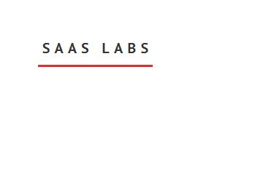

Made and Submitted by:

Riya Saxena

Email: [riyaa.saxena02@gmail.com](mailto:riyaa.saxena02@gmail.com)

College name: KIET Group of Institutions

**Objective:** Create an app for setting up workflow automations.

**Technologies used:** HTML, CSS, Bootstrap, JavaScript, PHP, MySQL.

**Tools used:** Visual studio code, Xampp (Apache server), Google chrome.

This is the home page. It contains the welcome message, 3 trigger options and the option of meeting the developer, which contains a devcard.

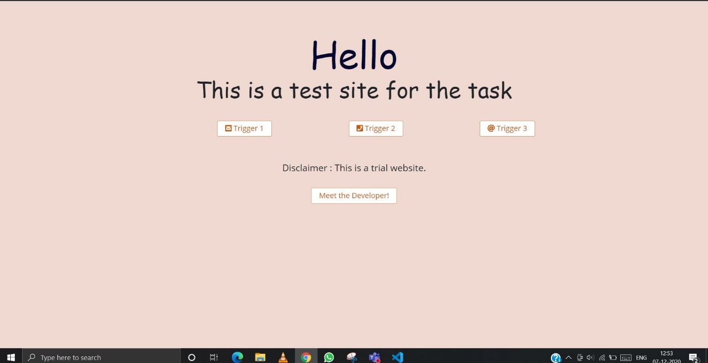

On clicking the 1st trigger, this form opens. It contains number from where message initiates, to the number is sent and the date of the message sent/received.

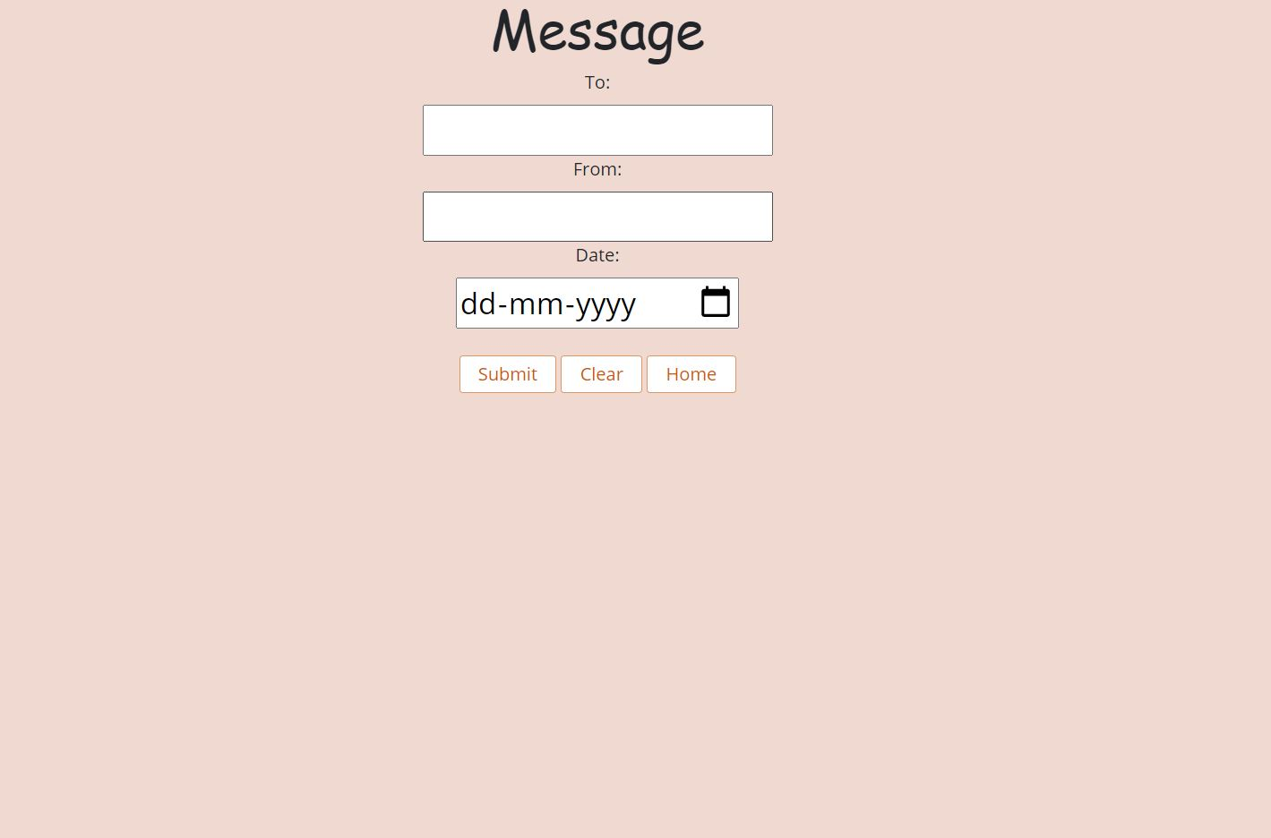

This is the 2nd trigger.  It contains from the number using which the call is made, To the number the call is made, Date of the call made/received and Call duration.

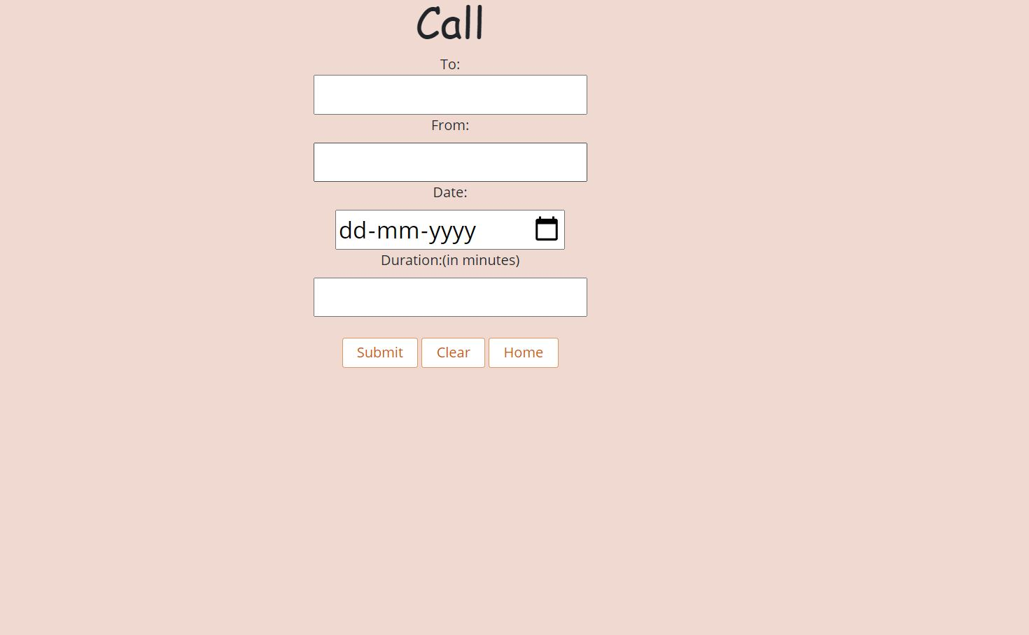

This is the 3rd trigger. It contains appointment date and email address of the person.

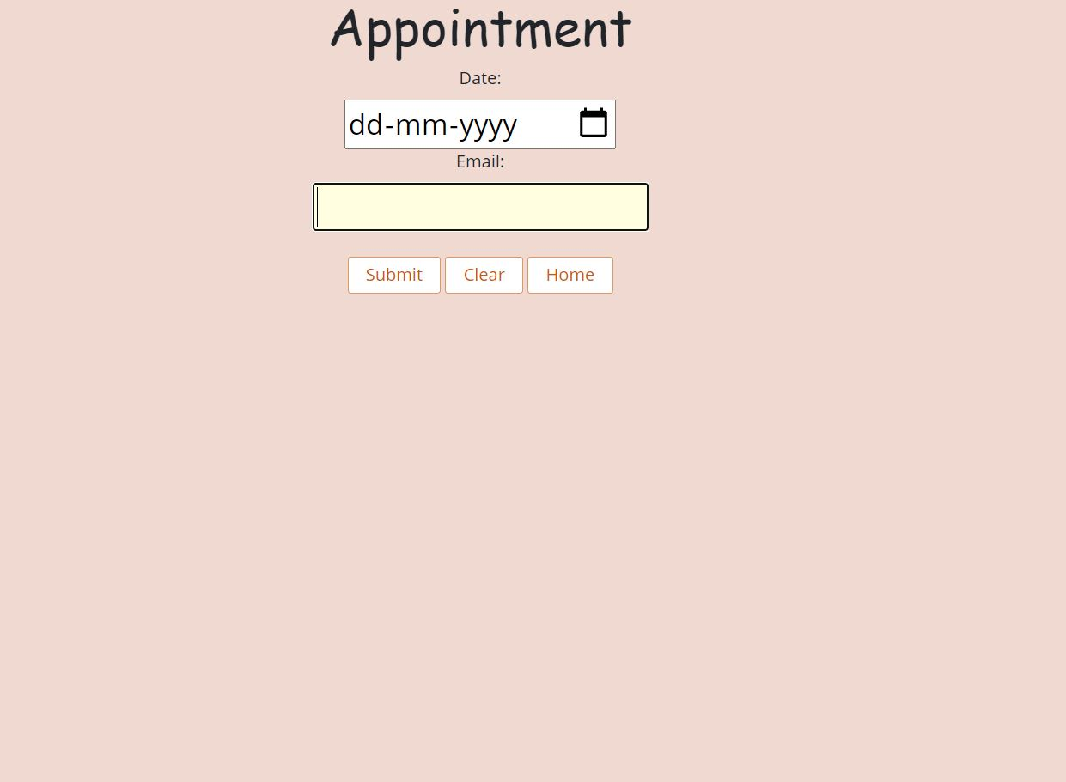

All the trigger pages contain 3 buttons- submit, clear and home.

The submit button will save the data to the database. The clear option will clear all the data written. Home button will redirect to the 1st page.

The backend working: